offset | glyph | name | alternate glyphs
xx00 | 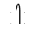 | QUICKSCRIPT LETTER PEA | 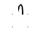
xx01 | 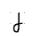 | QUICKSCRIPT LETTER BAY
xx02 | 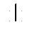 | QUICKSCRIPT LETTER TEA | 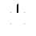
xx03 | 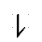 | QUICKSCRIPT LETTER DAY | 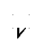
xx04 | 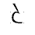 | QUICKSCRIPT LETTER KEY
xx05 | 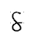 | QUICKSCRIPT LETTER GAY
xx06 | 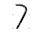 | QUICKSCRIPT LETTER THAW
xx07 | 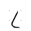 | QUICKSCRIPT LETTER THEY | 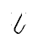
xx08 | 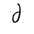 | QUICKSCRIPT LETTER FEE
xx09 | 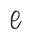 | QUICKSCRIPT LETTER VIE
xx0A | 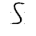 | QUICKSCRIPT LETTER SEE
xx0B | 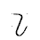 | QUICKSCRIPT LETTER ZOO | 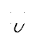
xx0C | 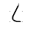 | QUICKSCRIPT LETTER SHE
xx0D | 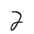 | QUICKSCRIPT LETTER J-AI
xx0E | 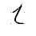 | QUICKSCRIPT LETTER CHEER
xx0F | 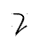 | QUICKSCRIPT LETTER JAY
xx10 | 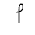 | QUICKSCRIPT LETTER YE
xx11 | 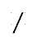 | QUICKSCRIPT LETTER WAY | 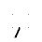
xx12 | 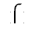 | QUICKSCRIPT LETTER HE | 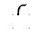
xx13 | 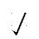 | QUICKSCRIPT LETTER WHY | 
xx14 | 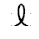 | QUICKSCRIPT LETTER ING
xx15 | 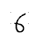 | QUICKSCRIPT LETTER MAY | 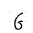
xx16 | 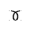 | QUICKSCRIPT LETTER NO | 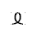
xx17 | 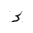 | QUICKSCRIPT LETTER LOW
xx18 | 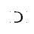 | QUICKSCRIPT LETTER ROE
xx19 | 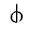 | QUICKSCRIPT LETTER LOCH
xx1A |  | QUICKSCRIPT LETTER LLAN
xx1B | 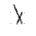 | QUICKSCRIPT LETTER EXCITE
xx1C | 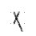 | QUICKSCRIPT LETTER EXAMINE
xx1D |  | (this position shall not be used)
xx1E |  | (this position shall not be used)
xx1F |  | (this position shall not be used)
xx20 | 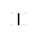 | QUICKSCRIPT LETTER IT
xx21 | 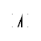 | QUICKSCRIPT LETTER EAT
xx22 |  | QUICKSCRIPT LETTER ET
xx23 | 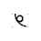 | QUICKSCRIPT LETTER EIGHT
xx24 | 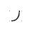 | QUICKSCRIPT LETTER AT
xx25 | 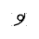 | QUICKSCRIPT LETTER I
xx26 | 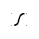 | QUICKSCRIPT LETTER AH
xx27 | 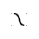 | QUICKSCRIPT LETTER AWE
xx28 | 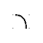 | QUICKSCRIPT LETTER OX
xx29 | 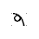 | QUICKSCRIPT LETTER OY
xx2A | 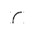 | QUICKSCRIPT LETTER UTTER | 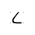
xx2B | 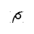 | QUICKSCRIPT LETTER OUT
xx2C | 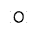 | QUICKSCRIPT LETTER OWE
xx2D | 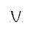 | QUICKSCRIPT LETTER FOOT
xx2E | 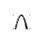 | QUICKSCRIPT LETTER OOZE
xx2F |  | QUICKSCRIPT NAMER DOT

 | xx0x | xx1x | xx2x
0
1
2
3
4
5
6
7
8
9
A
B
C
D
E
F

